THE UNITED REPUBLIC OF TANZANIA
THE EXPORT PROCESSING ZONES AUTHORITY
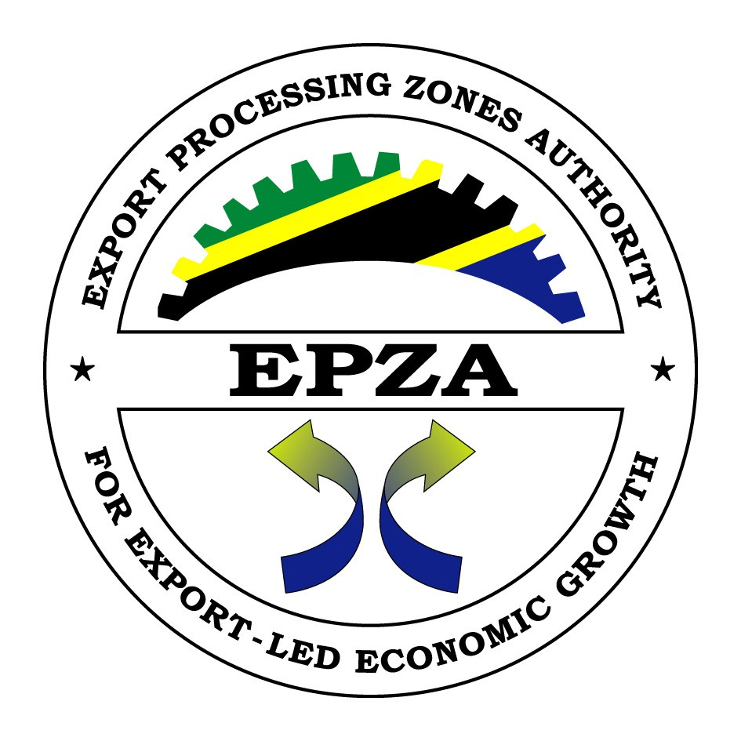
REQUEST FOR EXPRESSION OF INTEREST TO INVEST IN THE VARIOUS INDUSTRIAL AREAS UNDER EXPORT PROCESSING ZONES AUTHORITY EPZ OR SEZ SCHEMES

- The Export Processing Zone Authority (EPZA) is an autonomous Government Agency under the Ministry of Investment, Industry and Trade. The Authority was established in 2006 following amendment of the EPZ Act of 2002.

- The Authority main statutory function is to identify and earmark areas suitable for investment as special economic zones and thereon develop basic on-site and off-site infrastructures for the purpose of promoting enterprise investment to locate within Export Processing Zones (EPZ) and Special Economic Zones (SEZ).

- In 2022, the Authority was allocated by the government through Treasury Registrar several parcels of land and factories located in different regions in the country. The Authority wish to team up with competent strategic investors with the capability to mobilize resources to either rehabilitate existing factories or construct new industries/ industrial parks. The selected investors may choose to invest in any preferred sector considered feasible and that comply with EPZA laws. The successful investor may be leased the land or existing properties for a period not less than 33 years in a renewable term. In addition, the successful investor may opt to invest on the parcel of lands or existing factory buildings on a concession agreement to be negotiated with the Authority.

- The location of the project areas are as follows:

Lot No. | Region | Project Location and Land Size | Description | Preferred Investment type
1 | Dar es Salaam | Plot Nos 184/185/1 & 186/185/2 located at Chang’ombe Industrial area, Temeke, Dar es Salaam. The total size of plots is 8.39 acres (3.395 hectares) | The area was formally under National Steel Company. It is manly an open land with office blocks, gate house, workshop, garage and weighbridge. The area is easily accessed by road and well connected with utilities (water and electricity) | Any type of manufacturing activities/ industrial park
2 | Dar es Salaam | Plots No 1081 (Local Plots Nos. 1-7) Mabibo External, Ubungo District, Dar es Salaam. The total area is approx. 15,000 sqm. | The project area is part of Benjamin William Mkapa Special Economic Zone which was formally meant for commercial purposes. | Investment related to commercial activities.
3 | Tanga | Mkata Village, Farm No. 11 along Mkata – Handeni road, about 1km from the junction of DSM-Tanga road at Mkata Village, Handeni District.  The project area is 36 acres (14.63 hectares) | The area formally known as Mkata Sawmill has only dilapidated factory buildings and plants which are beyond repair. The area is well connected with utilities (water and electricity) and easily accessed through Mkata – Handeni road. | Investment related to Industrial Park in agro processing and the likes
4 | Lindi | Plot No. 3, Block “J”, Nachingwea Industrial Area, Nachingwea District.  The project area is 9.97 acres (4.035 hectares) | The area was formally a Nachingwea Cashewnut factory. It has an existing Industrial building, warehouse wing, office block and a weighbridge. These structures need rehabilitation. The area is well connected with utilities (water and electricity) | Investment related to Industrial Park in agro processing and the likes
5 | Lindi | Mafuta Ilulu, Nachingwea Industrial Area, Nachingwea District,  The area is 9.81 acres (3.971 hectares) | The area was formerly used as a sesame edible oil processing plant. The factory has an existing godown, and structures which need rehabilitation.  The area is connected to utilities (electricity and water). | Investment related to Industrial Park in agro processing and the likes
6 | Shinyanga | Tanganyika Packers Ltd  Plot No. 1 and Plot No. 15/1, Mwalugoye, Shinyanga.  Plot No. 1 has an area of 80. 03 acres (32.4 hectares), and Plot No. 15/1 has an area of 1099.2 acres (445.02 hectares) making the total area available to be 1179.23 acres (477.42 hectares) | The area is a former Meat Processing factory. Several factory buildings which are still in good shape and rest of the area was used as a cattle holding ground. In year 2022, the Government prepared a master plan for the establishment of Special Agro-Processing Zone (SAPZ) which was designed to occupy 200 hectares (out of 445 hectares of holding ground land). The remaining 245 hectares, is yet to be planned. | Investment related to Industrial Park or Special Economic Zone focusing in agro processing, livestock, mining processing and other related sectors
7 | Mbeya | Tanganyika Packers Ltd  Plot No. 760, Chunya Road, Mbalizi, Mbeya.  The area size is 252.39 acres | The area has uncompleted building which was meant to be a meat processing factory.  The factory building and some of the installed machines are still in good shape but need repairs. | Investment related to Industrial Park or Special Economic Zone focusing in agro processing, livestock, mining processing and other related sectors

- The Authority hereby invites eligible local and international industrial estate developers or consortia to submit their expression of interest to invest and develop the proposed industrial areas. Interested firms must provide information indicating their interest and capacity to partner with the Authority to invest on the said area, by submitting the following:

- Company profile including all subsidiary or associated companies, and indicating principle place of business;

- Certified copy of certificate of incorporation/registration;

- Certified copies of tax compliance and tax clearance from the country of principle place of business, together with VAT Certificate of Registration;

- Conceptual narrative, and layout designs of the proposed project;

- Evidence of experience in executing similar projects, describing projects undertaken in the last five years (Completed and on-going, if any);

- Evidence of technical, and financial capabilities including latest Audited Financial statement(s);

- Information regarding any litigation, current or within the last five years, parties involved, nature of dispute and dispute amount;

- Letter of Reference from two (2) reputable financial institutions;

- Letter of Support from partners (Engineering, Procurement and Construction (EPC) contractors, financiers and professionals such as architects, engineers, quantity surveyors, project managers, legal advisors etc) identified for engagement in this project;

- Letter of Reference in good standing from the Chamber of Commerce in the country of principle place of business or from the Ministry responsible for industry on international trade and commerce of the same host country/province/state/canton of business;

- Companies may associate and create a Consortium to enhance their eligibility.

- Mode of developing the project will be as follows;

- Special Economic Zones: Design Build Operate and Transfer (DBOT) under a Concession Agreement; or
- Single factory: Long term Lease Agreement

- Interested investors are free to show interest to more than one Lot. However, no investor shall be allocated more than one lot.

- All compliant Expression-of-Interest submissions will be pre-qualified and successful applicants will be issued with Letters of Invitation to submit Request-for-Proposal (“RFP”) to invest and execute the project.

- Any costs incurred in relation to this expression of interest shall be borne by the respective applicants.

- Interested applicant who wish to visit the site and or obtain further information should contact Eng. Kenneth Haule, Mr. Kanuti Mosha and Nakadongo Fares whose mobile No. are 0767-830012, 0754-211178 and 0754800808 respectively. Expression of Interest documents shall be submitted to the Office of the Secretary, EPZA Tender Board, Plot No. 1081 off Nelson Mandela Road, Ubungo-Mabibo External, P.O. Box 12112 Dar es Salaam from 8:00hrs EAT. to 16:00hrs EAT, Monday to Friday except on public Holidays. Telephone + 255 22 2925058-60; E-mail address info@epza.go.tz

- Expressions of Interest (EoI) in writing, one in original plus one copy, must be sealed and clearly marked “EXPRESSION OF INTEREST TO DEVELOP (Name of the Project)” and delivered to the address below at or before 10:00hrs EAT on 05th June, 2023.

THE TENDER BOARD SECRETARY,
EXPORT PROCESSING ZONES AUTHORITY,
BWM SEZ, MABIBO EXTERNAL, OFF NELSON MANDELA RD,
P.O. Box 12112,
DAR ES SALAAM – TANZANIA
EMAIL: info@epza.go.tz
Tel: +255 22 2925058-60, Fax: + 255 22 2925861

Charles I. Itembe
DIRECTOR GENERAL

